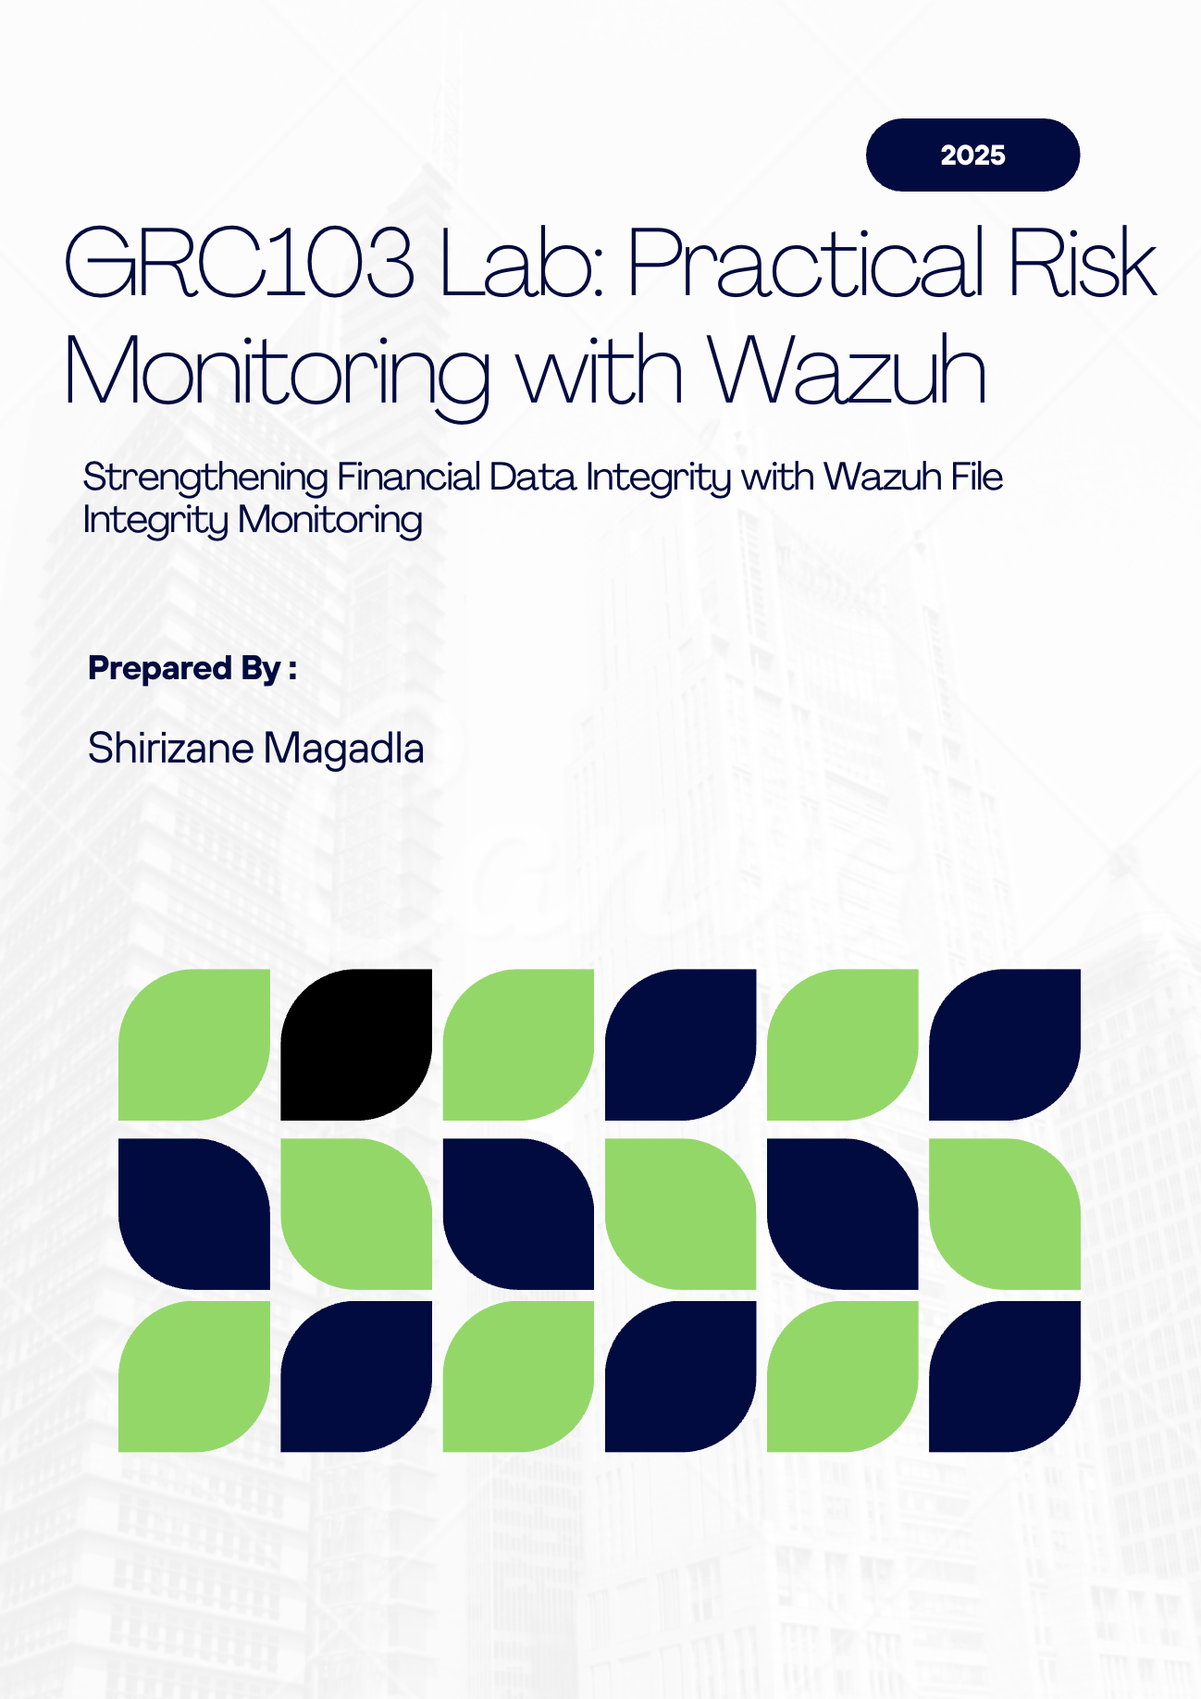

Strengthening Financial Data Integrity with Wazuh File Integrity Monitoring

Introduction
In today’s digital business environment, the integrity of our financial data is not just a technical concern; it is a cornerstone of our organization’s reputation, regulatory compliance, and operational resilience. Recent risk assessments have highlighted the threat of unauthorized modification or deletion of sensitive financial documents as a significant risk to our business. In response, we have implemented a File Integrity Monitoring (FIM) solution using the Wazuh platform. This report summarizes the business rationale, operational findings, and strategic value of this initiative, and outlines how it positions us for stronger governance and compliance.

1. Risk Identification and Business Impact

The Risk in Context
Our financial documents, such as quarterly forecasts and budget files, are critical assets. Unauthorized changes to these files, whether accidental or malicious, can have far-reaching consequences. The risk is not hypothetical: organizations across various industries have suffered from data tampering, resulting in regulatory fines, loss of investor confidence, and operational setbacks.

Potential Business Impact
- Financial Consequences:
Unauthorized modifications can result in inaccurate reporting, regulatory penalties, and costly audits. For example, breaches of SOX or GDPR can result in fines of up to €20 million or 4% of the company's annual revenue. The average cost of a data breach, including legal and recovery expenses, is nearly $5 million. Even a single incident can trigger a cascade of financial repercussions, from lost revenue to increased insurance premiums.
- Reputational Damage:
Trust is hard-won and easily lost. If stakeholders or the public learn that our financial data has been compromised, we risk losing investor confidence, damaging our brand, and facing negative media coverage. In some cases, companies have seen their market value drop by as much as 80% following a major data integrity incident.
- Operational Disruption:
When financial documents are altered or deleted without authorization, business processes grind to a halt. Teams must divert resources to investigate, recover, and restore data, delaying critical decisions and projects. In severe cases, regulatory investigations can further disrupt operations and even threaten our license to operate.

Why This Matters
The integrity of our financial data underpins every strategic decision we make. Protecting it is not just an IT issue, it is a business imperative.

2. Control Implementation: How Wazuh FIM Works

The Detective Control in Action
To address this risk, we deployed Wazuh File Integrity Monitoring on key workstations where sensitive financial documents are stored. Wazuh continuously monitors designated folders, logging every file creation, modification, and deletion. This detective control provides real-time alerts and a centralized audit trail, ensuring that any suspicious activity is immediately visible to our security and compliance teams.

Key Observations

During our recent monitoring period, Wazuh detected the following activity in the sensitive files directory:
- The key financial document (q4_financial_forecast.docx) was added, modified three times, and then deleted—all within a short window.
- Several temporary files associated with document editing were also created and deleted.
- All events were logged with precise timestamps and user attribution, providing a clear, actionable record.

This level of visibility transforms risk management from a theoretical exercise into a data-driven discipline. We can now quantify how often sensitive files are accessed or changed, identify patterns, and respond proactively to anomalies.

3. Control Evaluation and Treatment

Complementary Preventive Controls
While Wazuh FIM is highly effective at detecting and alerting us to unauthorized changes, prevention remains our first line of defense. To further reduce risk, we recommend:
- Restricting Access: Only authorized finance staff should have permission to modify or delete sensitive files. This can be enforced through folder permissions and user roles.
- Multi-Factor Authentication (MFA): Adding an extra layer of authentication for users accessing critical folders.
- File Encryption: Ensuring that even if files are accessed, they cannot be altered without proper authorization.

Corrective Controls in Practice
Detective controls are only as valuable as our ability to respond. For example, if Wazuh alerts us to a file modification at 2:00 AM by an unauthorized user, our response would include:
- Immediate investigation to confirm the nature of the change.
- Restoration of the original file from backup if the change was unauthorized.
- Temporary suspension of the user account involved, pending review.
- Review and tightening of access controls to prevent recurrence.

This layered approach of prevention, detection, and correction ensures that we not only catch incidents but also minimize their impact and prevent future occurrences.

4. Risk Monitoring and Reporting

Key Metrics for Management Oversight
To provide ongoing assurance to management, we track and report on three key metrics from the Wazuh dashboard:

- Number of File Integrity Alerts:
How many times have sensitive files been added, modified, or deleted? This helps us spot trends and identify periods of heightened risk.
- Most Active Users:
Who is interacting with our critical documents? This metric helps us detect unusual or unauthorized activity, supporting both operational oversight and insider threat detection.
- Time to Detection and Response:
How quickly do we detect and respond to incidents? Fast detection and response are crucial for minimizing business impact.

The Power of Centralized Monitoring
Centralizing all monitoring data in the Wazuh dashboard delivers several strategic advantages:
- Unified Oversight: We have a single, comprehensive view of all file activity across the organization, eliminating blind spots and ensuring no critical event is missed.
- Audit-Ready Evidence: Logs are automatically aggregated, timestamped, and secured, creating a tamper-evident audit trail. This is invaluable for compliance audits and forensic investigations.
- Streamlined Reporting: Management and auditors can access real-time and historical data in one place, making it easy to generate reports and demonstrate control effectiveness.
- Faster Incident Response: With all alerts visible in one dashboard, our teams can quickly identify, correlate, and respond to suspicious activity, reducing potential business impact.

5. Compliance & Audit Readiness

Meeting Regulatory Requirements
Many regulations, including SOX, PCI DSS, and HIPAA, require organizations to monitor critical files for unauthorized changes. Wazuh FIM helps us meet these requirements by:
- Continuously monitoring and logging all relevant file events.
- Centralizing logs in a secure, tamper-evident dashboard.
- Mapping alerts and events to specific regulatory controls makes it straightforward to demonstrate compliance.

Demonstrating Compliance to Auditors
When auditors request evidence that a specific file (e.g., the Q4 financial forecast) has not been altered during a given period, we can:
- Filter the Wazuh dashboard for the file and date range in question.
- Show that no "modified," "deleted," or "added" events occurred during that period.
- Export or screenshot the results as clear, audit-ready evidence.
This capability not only streamlines audits but also builds confidence with regulators and stakeholders.

6. Strategic Value and Next Steps

Moving from Theory to Practice
The deployment of Wazuh FIM marks a significant step forward in our risk management journey. We have moved from theoretical risk assessments to a practical, data-driven approach that delivers real-time visibility, actionable intelligence, and audit-ready evidence.

Recommendations
- Expand FIM Coverage: Extend monitoring to all critical business data and systems.
- Regularly Review Access Controls: Ensure only authorized personnel have access to sensitive files.
- Integrate FIM with Incident Response: Make FIM alerts a core part of our broader security operations.

Final remarks
Protecting the integrity of our financial data is not just about compliance; it is about safeguarding our reputation, supporting sound decision-making, and ensuring the long-term success of our organization. By investing in robust controls like Wazuh FIM, we demonstrate our commitment to operational excellence, regulatory compliance, and stakeholder trust.

In summary:
Wazuh File Integrity Monitoring empowers us to detect, quantify, and respond to risks to our most sensitive data. It provides the transparency, control, and evidence needed to meet today’s regulatory and business challenges, turning risk management from a checkbox exercise into a true business enabler.

Workflow Evidence for lab Preparation.

Locating the Wazuh server IP: 192.168.0.139 using sudo dhclient -v command

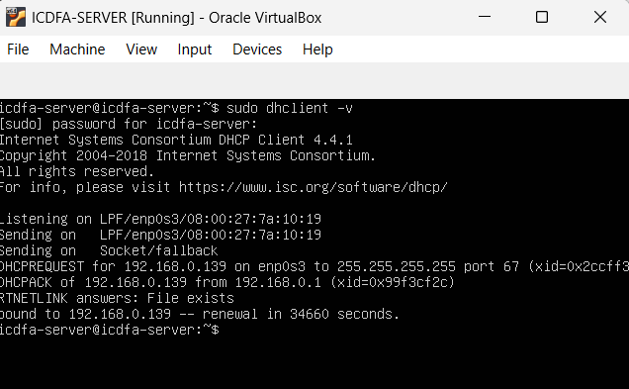

Ssh root@192.168.0.139 to be able to control the wazuh server on kali
Checking if the wazuh server is up using sudo systemctl status wazuh-manager command

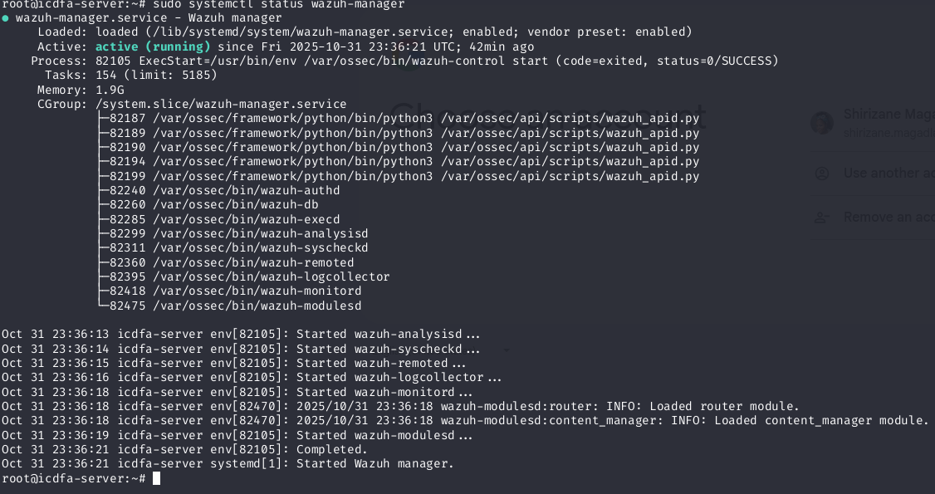

After creating the wazuh agent and the Sensitivefiles folder, the dashboard started getting traffic.

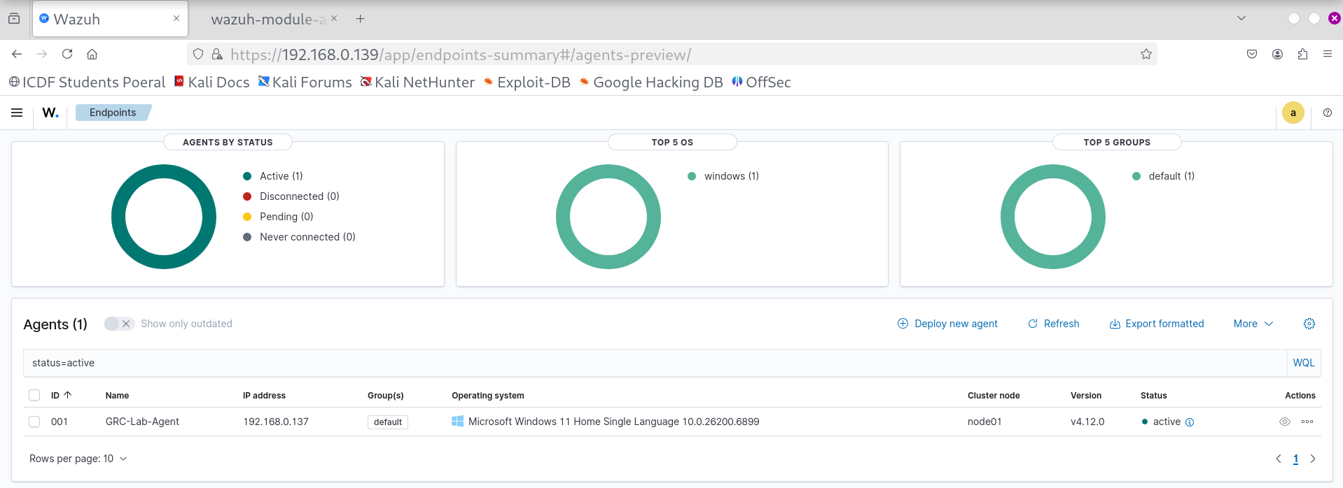

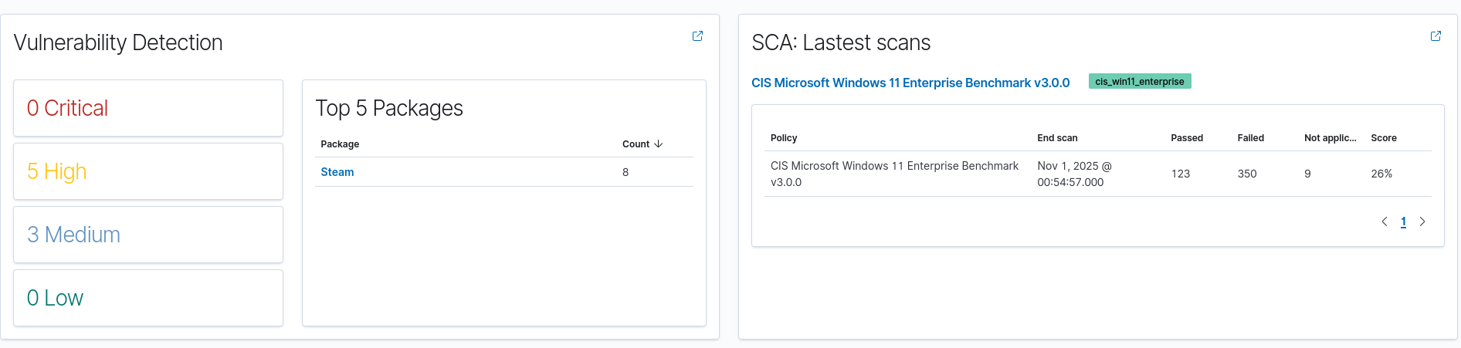

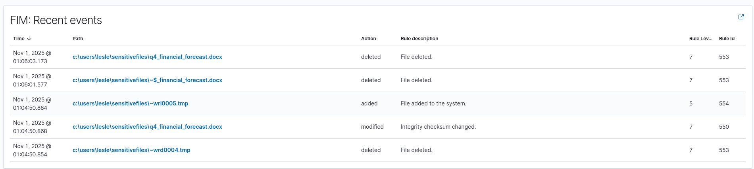

Link to FIM report: https://drive.google.com/file/d/1VKCLRZeTLBcResInSuOdzZWIQtxWhTS1/view?usp=sharing

